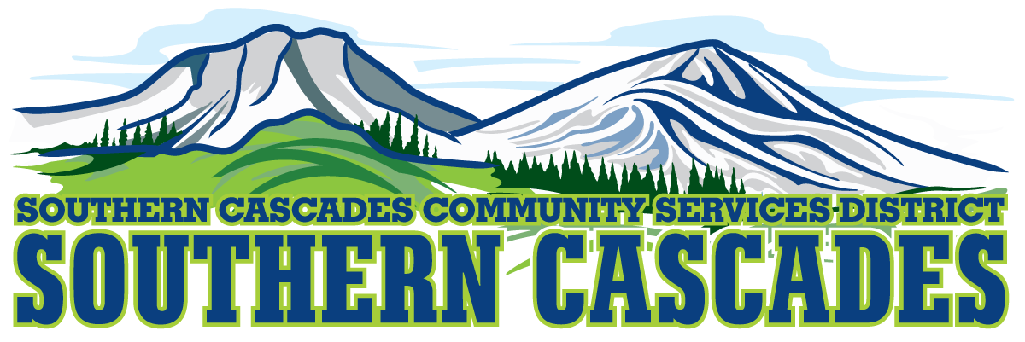  
205 Ash Valley Rd. PO Box 239, Adin, CA 96006

www.southerncascades.org

**FULL TIME POSITION**

**HEALTH TRANSPORT TECHNICIAN**

**$16.00 - $21.77**

**If you like People and Driving, we have a position open immediately**

SUCCESSFUL APPLICANTS MUST:

BE 18 YEARS OF AGE AND HAVE A CLEAN CLASS C CALIFORNIA DRIVERS LIC.

SUCCESSFULLY COMPLETE TRAINING PROVIDED BY EMPLOYER

BE ABLE TO PASS CRIMINAL BACKGROUND CHECK AND DRUG SCREENING

BE ABLE TO DRIVE IN ALL WEATHER CONDITIONS

**FOR APPLICATION OR INFORMATION**

**CALL 530 299-3110 or VISIT OUR WEBSITE AT WWW.SOUTHERNCASCADES.ORG**

**POSITION AVAILABLE IN SUSANVILLE**

SOUTHERN CASCADES CSD IS AN EQUAL OPPORTUNITY EMPLOYER AND SERVICE PROVIDER